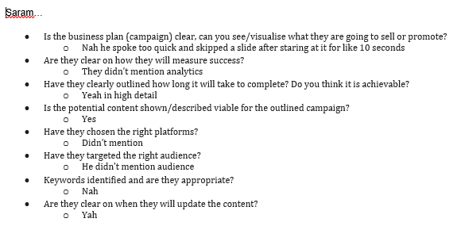

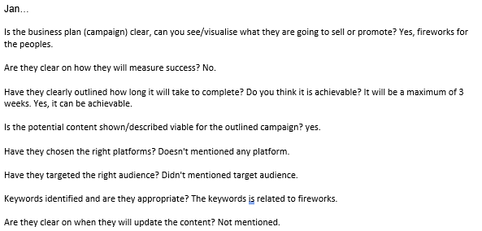

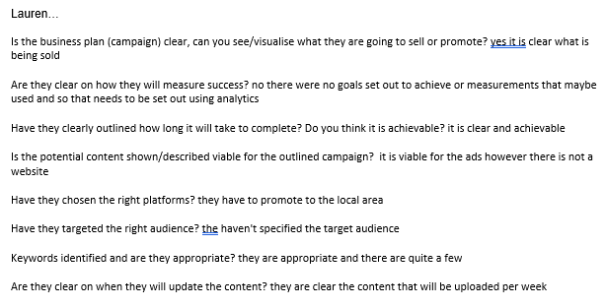

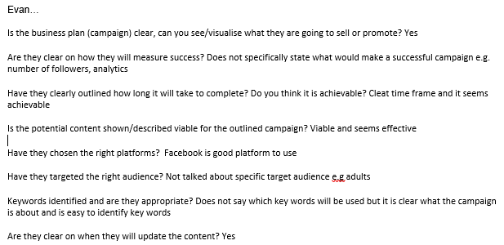

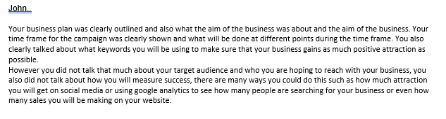

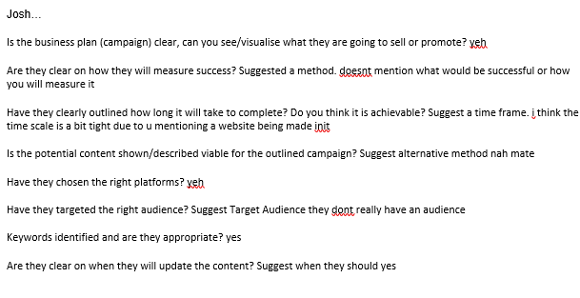

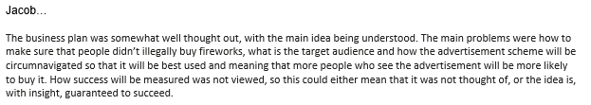

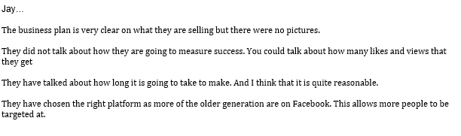

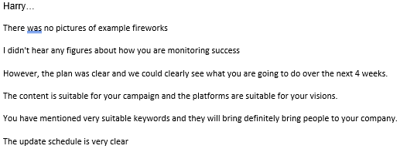

Summary: the feedback to my PowerPoint for ‘Build-A-Firework’ was mostly positive and saying that it was clear, concise and got the point across to the viewers and that they understood my intentions and thought that the time frame was acceptable and achievable, my keywords were related to the topic of homemade fireworks. A few complaints were the lack of colours and pictures or examples of fireworks; that I didn’t mention analytics, which I could have shown on google analytics or social media analytics such as YouTube analytics or twitter analytics, how to stop people who are underage from buying fireworks and that I didn’t mention a specific target audience.